**Implementation**

In this project we are implementing below algorithms

1. Random forest
2. C4.5 decision classifier
3. Navie bayes classifier
4. KNN
5. SVM
6. Decision tree classifier

**SVM (Support Vector Machine):**

In machine learning, support vector machines (SVMs, also support vector networks) are supervised learning models with associated learning algorithms that analyze data used for classification and regression analysis.

A Support Vector Machine (SVM) is a discriminative classifier formally defined by a separating hyper plane. In other words, given labeled training data (supervised learning), the algorithm outputs an optimal hyper plane which categorizes new examples.

An SVM model is a representation of the examples as points in space, mapped so that the examples of the separate categories are divided by a clear gap that is as wide as possible.

In addition to performing linear classification, SVMs can efficiently perform a non-linear classification, implicitly mapping their inputs into high-dimensional feature spaces.

Given a set of training examples, each marked as belonging to one or the other of two categories, an SVM training algorithm builds a model that assigns new examples to one category or the other, making it a non-probabilistic binary linear classifier.

**Naive Bayes:**

Naive Bayes is a classification algorithm for binary (two-class) and multi-class classification problems. The technique is easiest to understand when described using binary or categorical input values.

It is called naive Bayes or idiot Bayes because the calculations of the probabilities for each hypothesis are simplified to make their calculation tractable. Rather than attempting to calculate the values of each attribute value P(d1, d2, d3|h), they are assumed to be conditionally independent given the target value and calculated as P(d1|h) * P(d2|H) and so on.

This is a very strong assumption that is most unlikely in real data, i.e. that the attributes do not interact. Nevertheless, the approach performs surprisingly well on data where this assumption does not hold.

**KNN (K NEAREST NEIGHBORS):**

K-Nearest Neighbors is one of the most basic yet essential classification algorithms in Machine Learning. It belongs to the supervised learning domain and finds intense application in pattern recognition, data mining and intrusion detection.

It is widely disposable in real-life scenarios since it is non-parametric, meaning, it does not make any underlying assumptions about the distribution of data (as opposed to other algorithms such as [GMM](https://en.wikipedia.org/wiki/Mixture_model), which assume a Gaussian distribution of the given data).

We are given some prior data (also called training data), which classifies coordinates into groups identified by an attribute.

K can be kept as an odd number so that we can calculate a clear majority in the case where only two groups are possible. With increasing K, we get smoother, more defined boundaries across different classifications. Also, the accuracy of the above classifier increases as we increase the number of data points in the training set.

**DECISION TREE (C4.5):**

Decision tree is the most powerful and popular tool for classification and prediction. A Decision tree is a flowchart like tree structure, where each internal node denotes a test on an attribute, each branch represents an outcome of the test, and each leaf node (terminal node) holds a class label.

Decision trees classify instances by sorting them down the tree from the root to some leaf node, which provides the classification of the instance. An instance is classified by starting at the root node of the tree, testing the attribute specified by this node, then moving down the tree branch corresponding to the value of the attribute .This process is then repeated for the sub tree rooted at the new node. Representation of tree is shown below:

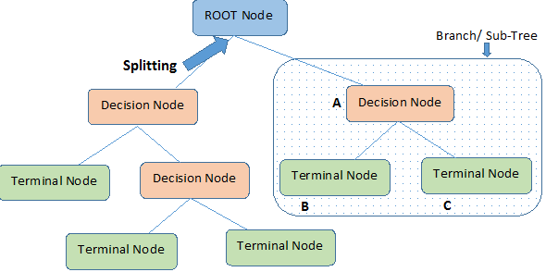

**Random Forest**

**A large number of relatively uncorrelated models (trees) operating as a committee will outperform any of the individual constituent models.** The low correlation between models is the key. Just like how investments with low correlations (like stocks and bonds) come together to form a portfolio that is greater than the sum of its parts, uncorrelated models can produce ensemble predictions that are more accurate than any of the individual predictions.